Assignment 9.1

Implementing Trees
Course Code: CPE010 | Program: BSCPE
Course Title: Data Structures and Algorithms | Date Performed: 9/25/25
Section: CPE21S4 | Date Submitted: 9/29/25
Name(s): Avila, Vince Gabriel V. | Instructor: Engr. Jimlord Quejado
6. Output
1. Define what is a binary tree?
A binary tree is a data structure in which each data element, called a node, can connect to two different nodes: one on the left and one on the right. It begins with one central node called the root node at the top of the structure. Binary trees enable you to organize and access data quickly. A binary tree is similar to a family tree where, for each individual, they can only have two branches. Binary trees are used in many applications in computer programming to organize information. For searching and sorting data, binary trees are much faster and more efficient than a simple list.
2. What are the key components of a Binary tree?
The main elements of a binary tree are the root or first node, the left child and right child, and the leaves or nodes with no children. Each node holds some data and connects it to the other nodes in the entire tree, which is composed of all of the nodes connected. The structure can be visualized as a diagram that has branches and grows downward. Parents are nodes that have children, and subtrees are smaller portions of the tree. The elements work together to make the tree useful for storing data as well as for finding data.
3. What are the operations that can be performed in a Binary tree?
A binary tree allows for adding nodes, removing nodes, and searching for specific values. We can also traverse the tree using different orders to view the data that exists within the structure. This allows us to organize, maintain, and utilize the data more effectively. Essentially this is similar to sorting and searching for items in a list at a rate faster than simply scanning a list. Additionally, we can determine the height of the tree and the depth of a particular node. There are important implications for maintaining the binary tree balance and efficiency through these operations.
4. What are the conditions for a Binary Search Tree?
In a binary search tree, the left side of a node must have smaller values, and the right side must have bigger values. This restriction is used to help us search through the tree quickly and easily. Every section of the tree must maintain this restriction. Just like we keep numbers in order to make them quicker to search, the rules of a binary search tree help us keep things in order. If we follow the restrictions, the tree is neat and easy to use. If we break the restrictions, the tree will no longer be efficient and orderly.
5. Give a simple sample program in C++ that uses the above algorithm. Explain how the program works.
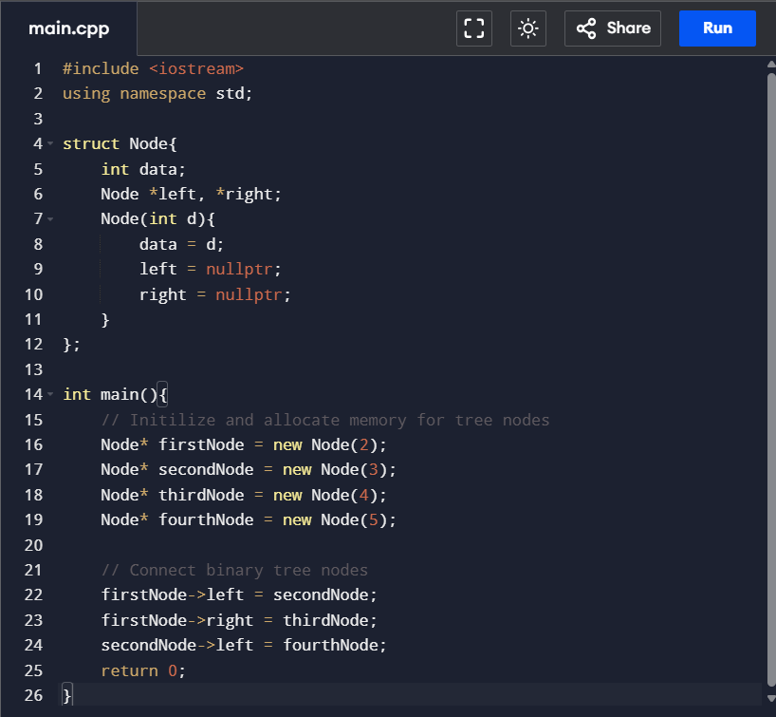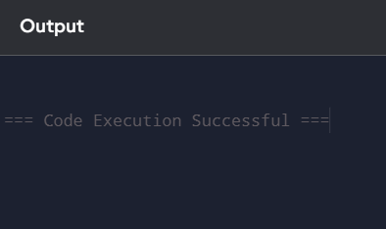

Analysis:
This program demonstrates a small binary tree utilizing a structure known as `Node`. Each `Node` contains a number and can have two pointers to nodes, one to the left and one to the right. In `main`, we create four nodes containing the values 2, 3, 4, and 5. We can also connect these nodes together so that 2 becomes the root, 3 takes the place as the left child of the root, 4 as the right child of the root, and 5 becomes the left child of 3. This illustrates the manual linking of nodes to formulate a tree arrangement. This code demonstrates one of the simplest ways to illustrate how a binary tree is created and used in C++.

References:
GeeksforGeeks. (2025d, August 19). Introduction to Binary tree. GeeksforGeeks. https://www.geeksforgeeks.org/dsa/introduction-to-binary-tree/

8. Conclusion
In conclusion, I learned that a binary tree is a data structure that organizes data in a structure consisting of a node, with a node linked to another node on the left and a node linked to another node on the right. The binary tree explains the rules of a binary search tree as well. The C++ example was a nice, clear example of how to create binary trees using pointers. It was a great example resource for introducing the binary tree to beginner programmers. Experiencing this structure will help with handling data, as data can be sorted in a much faster manner.

9. Assessment Rubric

